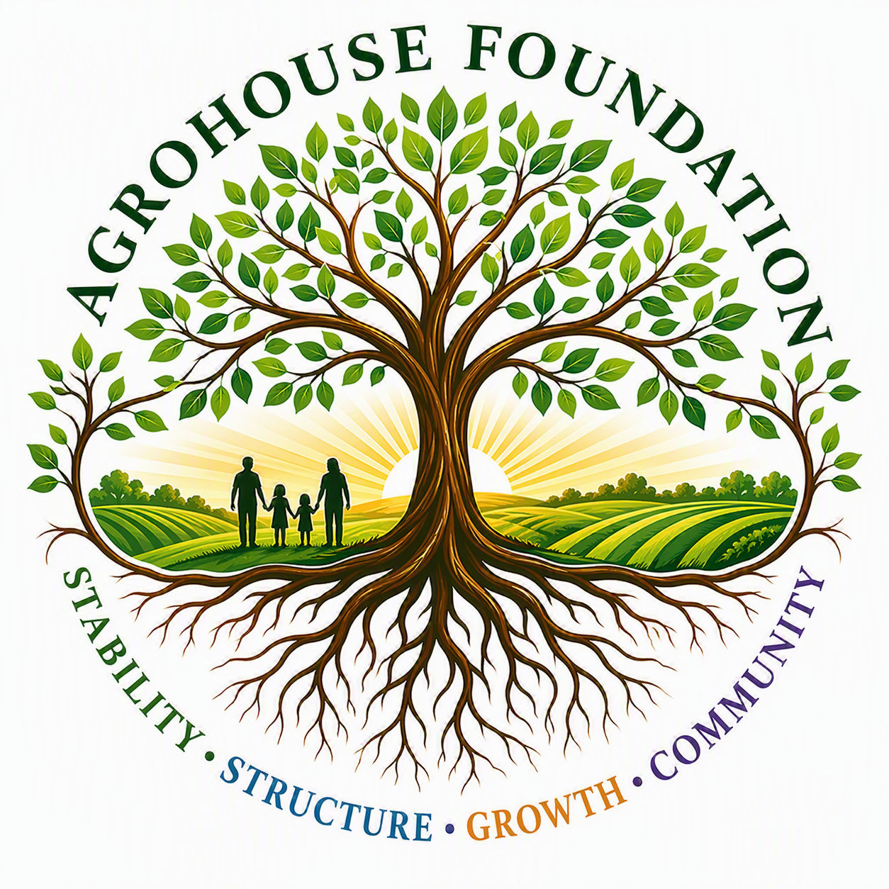
MARKETING & PARTNERSHIP PORTFOLIO
Community Outreach Stabilization • Wesley Chapel, Zephyrhills, Dade City, Land O' Lakes & East Pasco County, FL
AGHF INC.
d/b/a AgroHouse Foundation
Prepared for community, donor & sponsor conversations by:
Susan Slater
Marketing & Fundraising Manager | Treasurer & Director

WHO WE ARE
Mission & Vision
AgroHouse Foundation exists to strengthen communities through outreach stabilization, food security, sustainable agriculture, workforce development opportunities, and future vocational housing systems that promote long-term stability, self-sufficiency, and dignity.
Vision: A sustainable ecosystem where outreach, agriculture, workforce development, and vocational opportunities work together to strengthen individuals, families, and communities.
Core Values
- Stability — Creating reliable systems that communities can depend upon.
- Sustainability — Building long-term solutions rather than temporary responses.
- Stewardship — Managing resources responsibly, ethically, and transparently.
- Community — Working alongside existing organizations and community partners rather than replacing them.
- Opportunity — Creating pathways for growth, education, employment, and self-sufficiency.
- Dignity — Serving individuals with respect while preserving personal choice, independence, and self-worth.
Where We Stand
AGHF Inc. is a Florida nonprofit corporation, formed and operating under a debt-free, grant- and donation-supported model. The organization is currently pursuing federal 501(c)(3) tax-exempt status; until that determination is granted, charitable contributions to AgroHouse Foundation may not yet be tax-deductible. Program 1, our Community Outreach Stabilization Program, is our active operating priority.

WHAT WE DO
Program 1: Community Outreach Stabilization
Program 1 strengthens existing outreach efforts through the procurement and distribution of meals, hygiene resources, hydration resources, logistical support, storage solutions, and community support infrastructure. The program is currently in active development in the Wesley Chapel, Zephyrhills, Dade City, Land O' Lakes, and East Pasco County areas of Florida.
AgroHouse Foundation Does:  - Provide stabilization support  - Procure resources  - Build infrastructure  - Coordinate logistics  - Develop future sustainability systems | AgroHouse Foundation Does Not:  - Operate church outreach activities  - Supervise church volunteers  - Manage church donations  - Control church programming

Community Partnership in Action
AgroHouse Foundation supports the outreach operated by First Nazarene Church of Zephyrhills through resource procurement, meal support, hydration stations, and hygiene blessing bags. AgroHouse Foundation supports and strengthens this outreach but does not control, manage, supervise, or direct the church's programming or volunteers.
Current planning estimates, based on direct observation by AGHF leadership, support approximately 125 individuals reached per week through this partnership; figures are reviewed and updated as outreach evolves.

GROWING TOGETHER
Program 1 at a Glance
~125  Individuals reached weekly (current estimate) | 3  Outreach days per week — Mon / Wed / Fri | 5  Focus counties & communities served

These figures reflect current planning estimates for an actively developing program and are updated as Program 1 grows. AgroHouse Foundation avoids exaggerated impact claims and reports only verified or clearly labeled estimated activity.
What Your Support Provides
- Meals and meal-service supplies for outreach guests
- Coffee, tea, and hydration station resources
- Hygiene “blessing bags” assembled and distributed to individuals in need
- Storage, transport, and logistics infrastructure that keeps resources flowing reliably
- Program administration, compliance, and grant-readiness so support reaches the community efficiently
Looking Ahead
Beyond Program 1, AgroHouse Foundation is developing a phased path toward sustainable agriculture (Program 2), workforce development and education (Program 3), and vocational housing (Program 4) — each requiring its own funding, capacity, and Board approval before launch.

WAYS TO PARTNER
Become a Community Partner
AgroHouse Foundation welcomes local businesses, congregations, and individuals who want to invest in a debt-free, community-driven organization. Partnership levels below are illustrative starting points for conversation — final tier names, benefits, and amounts should match the Board-approved Sponsorship Strategy.
Community Partner
An entry-level, no-pressure way to support Program 1 on a recurring or one-time basis.
- Name listed on AgroHouse Foundation's community partner materials
- Periodic impact updates from the Program Manager
- Suggested level: [to be confirmed with Board-approved sponsorship strategy]
Outreach Partner
For businesses and organizations ready to make a visible, ongoing commitment to outreach stabilization.
- Recognition at outreach events and on printed materials
- Option to volunteer alongside AgroHouse Foundation activities
- Suggested level: [to be confirmed with Board-approved sponsorship strategy]
Founding Partner
For lead supporters helping launch and stabilize Program 1 during this formative stage.
- Premier recognition across AgroHouse Foundation communications
- Direct briefings on program growth and future phases
- Suggested level: [to be confirmed with Board-approved sponsorship strategy]

Other Ways to Give
- In-kind donations of food, hygiene items, or logistics support
- Corporate sponsorship of a specific outreach day or resource
- Volunteer time alongside our community partners
- Grant and foundation introductions
AgroHouse Foundation is pursuing federal 501(c)(3) tax-exempt status; deductibility of any contribution should be confirmed once that determination is received.

LET'S TALK
Get in Touch
Whether you're exploring a partnership, considering a donation, or simply want to learn more about AgroHouse Foundation, we'd welcome the conversation.
Susan Slater
Marketing & Fundraising Manager | Treasurer & Director
Maggie Baty
Founder, Chairperson & Executive Director
Email / Phone: [to be added]
Website: [to be added upon launch]
Service Area: Wesley Chapel, Zephyrhills, Dade City, Land O' Lakes & East Pasco County, FL

Stability • Structure • Growth • Community
AGHF Inc. d/b/a AgroHouse Foundation — Florida Nonprofit Corporation

